- OSI Model and Wireshark Analysis

1. Wireshark Capture and Protocols Observed
Objective
To capture and analyze network packets generated while accessing internet services using Wireshark.
Procedure
- Installed and opened Wireshark.
- Selected the Wi-Fi network interface.
- Started packet capture.
- Accessed websites and internet services while the capture was running.
- Applied filters to observe specific protocols.
- Stopped the capture and analyzed the packets.
Screenshots
Figure 1: Packet capture showing protocols such as TCP, TLSv1.3 and QUIC.
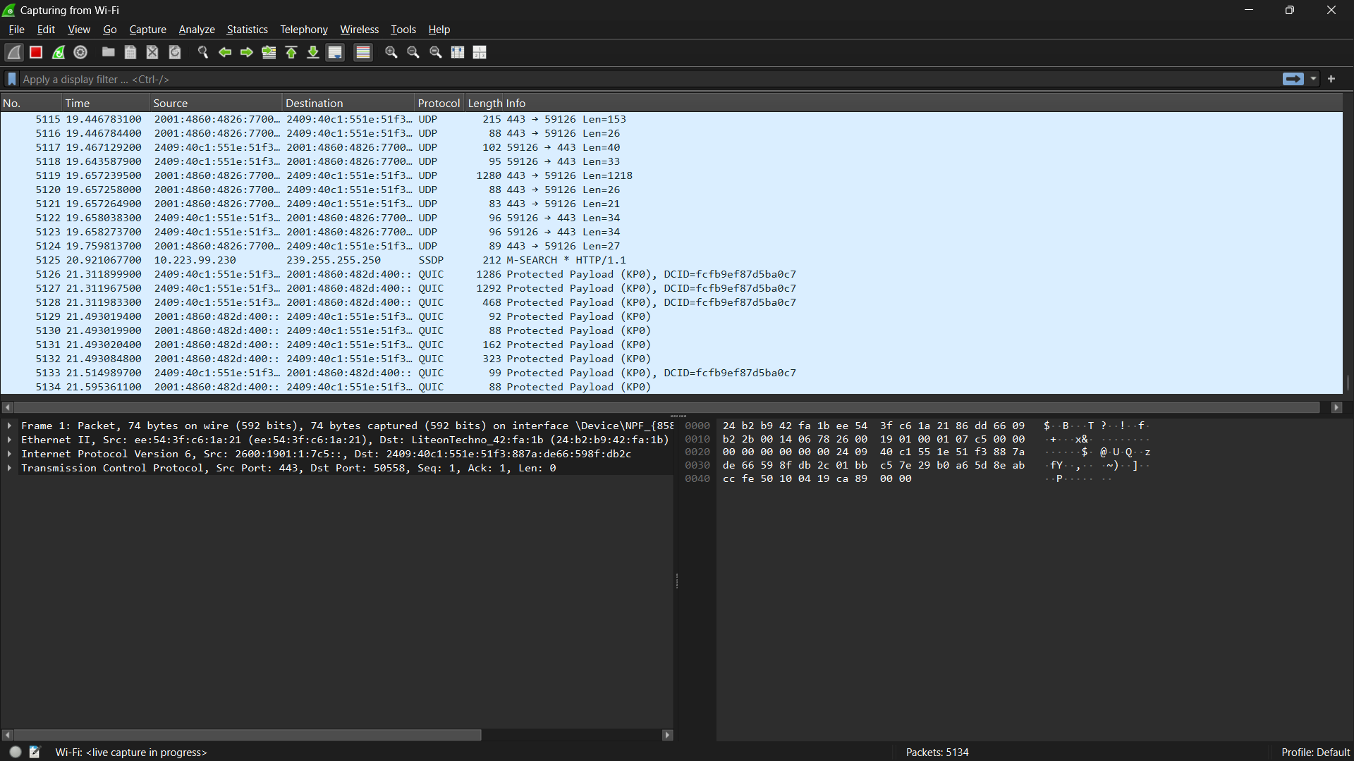
Figure 2: DNS-filtered capture showing domain name resolution packets.
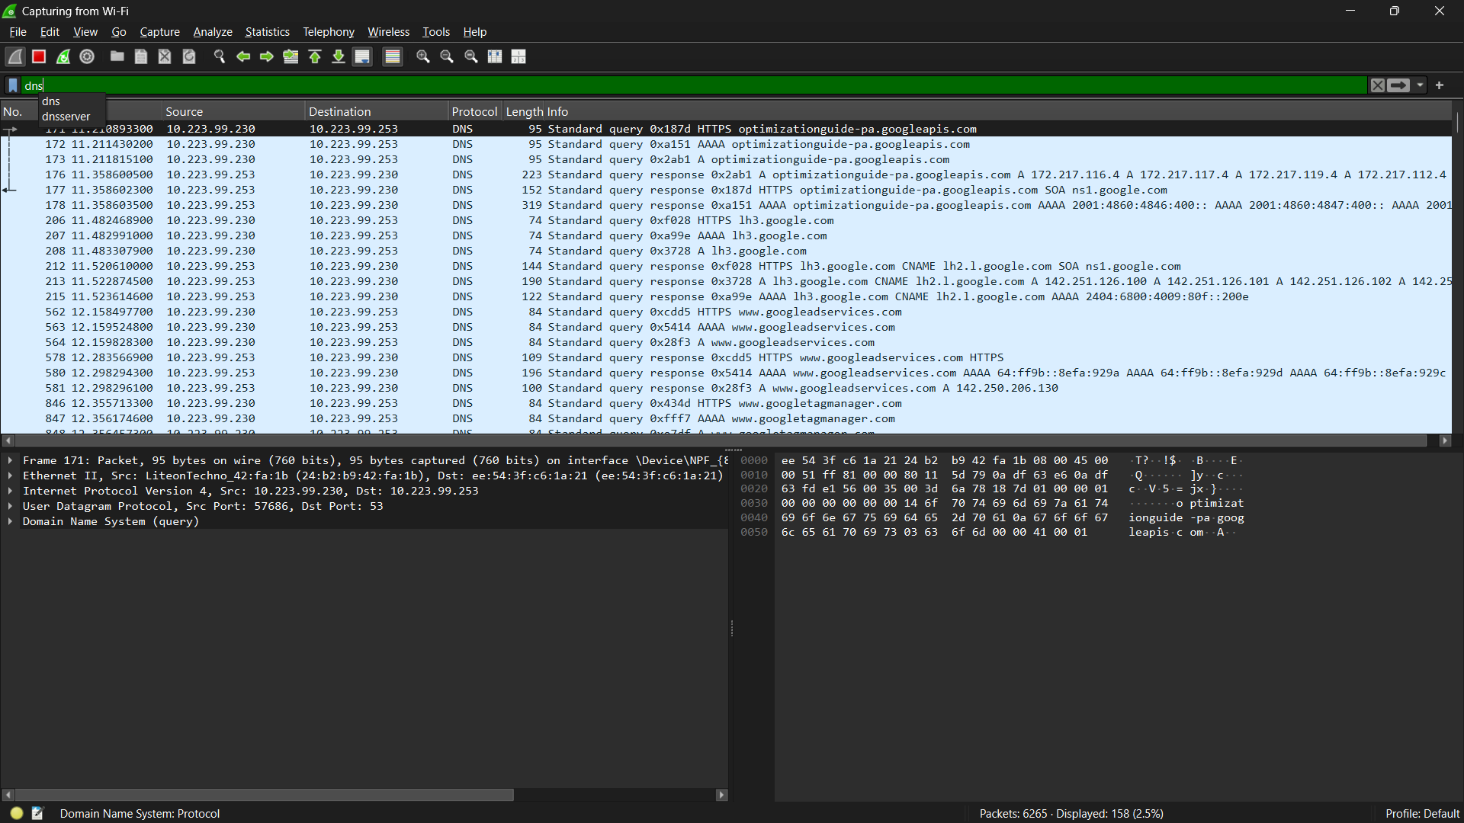
Protocols Observed
Protocol | Purpose
DNS | Converts website names into IP addresses
TCP | Provides reliable communication between devices
TLSv1.3 | Encrypts data exchanged over the internet
QUIC | Fast and secure communication used by modern websites and applications
Explanation of Protocols
DNS (Domain Name System)
DNS translates human-readable names such as:
www.google.com
into IP addresses that computers can understand.
TCP (Transmission Control Protocol)
TCP establishes a reliable connection and ensures that data arrives correctly and in order.
TLSv1.3 (Transport Layer Security)
TLS encrypts network communication and protects user data from being read by unauthorized users.
QUIC
QUIC is a modern transport protocol used by many websites. It provides faster communication and improved performance compared to traditional TCP connections.
Observation
During packet capture, DNS requests and responses were observed along with TCP, TLSv1.3 and QUIC traffic. The DNS packets showed domain name resolution activity, while TLS and QUIC packets indicated secure encrypted communication.
Conclusion
Wireshark successfully captured network traffic on the Wi-Fi interface. The captured packets demonstrated how DNS resolves domain names and how modern internet communication uses TCP, TLSv1.3 and QUIC to provide secure and reliable connectivity.
2. Identifying OSI Layers from Wireshark Packets
Packet Analysis
Protocol | OSI Layer | Reason
DNS | Application Layer (Layer 7) | Resolves domain names to IP addresses
TCP | Transport Layer (Layer 4) | Provides reliable end-to-end communication
TLSv1.3 | Presentation Layer (Layer 6) | Encrypts and secures data
IP (seen inside packet details) | Network Layer (Layer 3) | Routes packets between networks
Example
Packet 1: DNS
- Protocol: DNS
- OSI Layer: Application Layer
- Function: Converts website names into IP addresses.
Packet 2: TCP
- Protocol: TCP
- OSI Layer: Transport Layer
- Function: Ensures reliable delivery of data.
Packet 3: TLSv1.3
- Protocol: TLSv1.3
- OSI Layer: Presentation Layer
- Function: Encrypts communication for security.
3. OSI Model Diagram
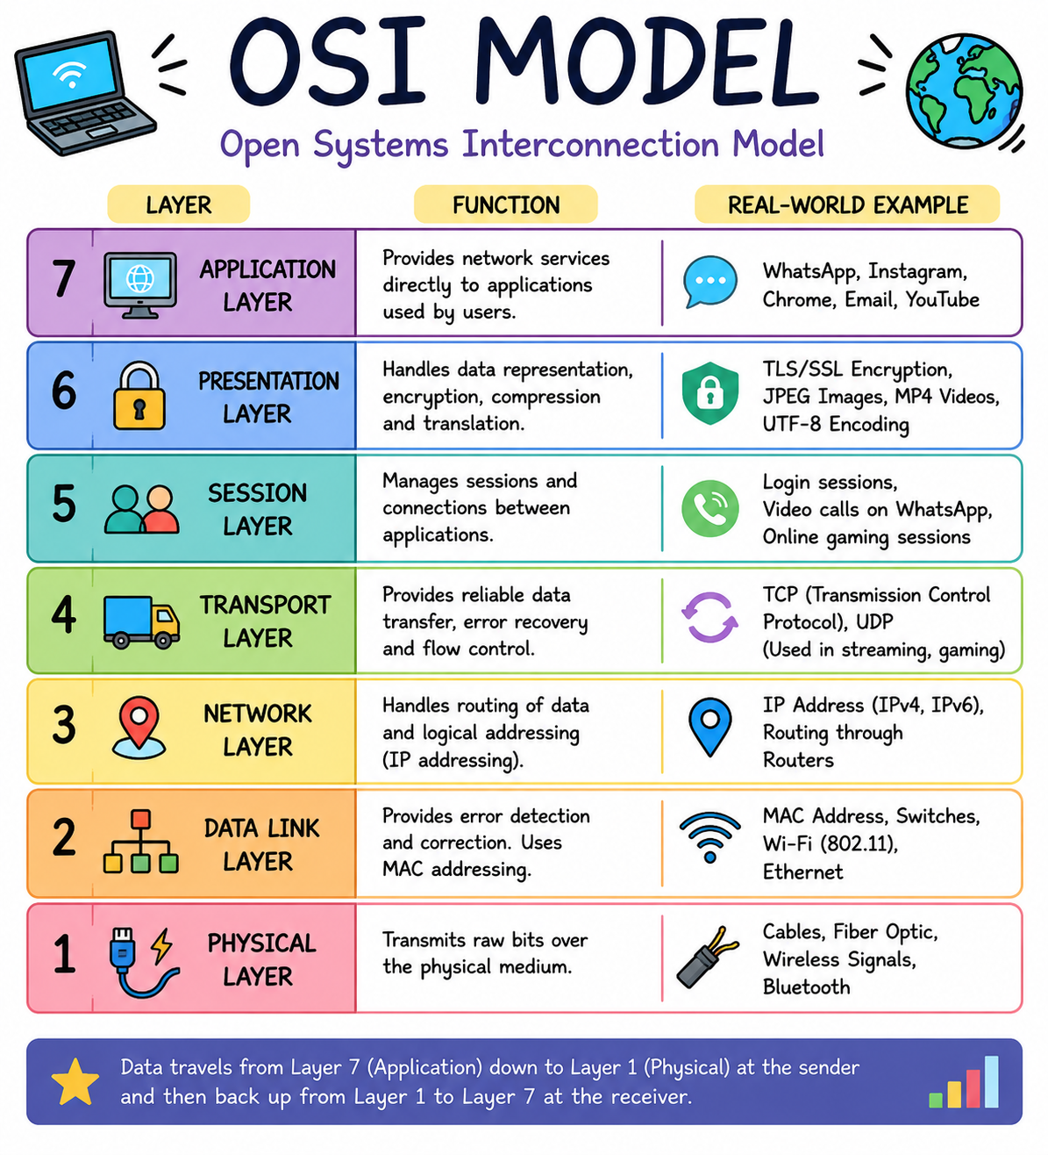
Real-World Examples
OSI Layer | Example
Application | WhatsApp, Instagram, Chrome
Presentation | TLS Encryption
Session | User Login Session
Transport | TCP, UDP
Network | IP Address
Data Link | Wi-Fi MAC Address
Physical | Wireless Signals, Ethernet Cable

4. How a WhatsApp Message Travels Through the OSI Model
Suppose I send the message:
Hello Friend
Layer 7 – Application Layer
I type the message in WhatsApp and press Send.
Layer 6 – Presentation Layer
WhatsApp encrypts the message so that only the receiver can read it.
Layer 4 – Transport Layer
TCP breaks the message into small segments and ensures reliable delivery.
Layer 3 – Network Layer
IP addresses are added so the message can reach the correct destination through the internet.
Layer 2 – Data Link Layer
The message is converted into frames and MAC addresses are added for communication within the local network.
Layer 1 – Physical Layer
The data is transmitted as electrical, radio, or wireless signals through Wi-Fi or mobile data.
At the Receiver Side
The process happens in reverse:
- Signals are received.
- Frames are processed.
- IP addresses are checked.
- TCP reassembles the message.
- WhatsApp decrypts the message.
- The receiver sees:
Hello Friend
Conclusion
Wireshark was used to capture network traffic and identify protocols such as DNS, TCP, TLSv1.3, and QUIC. These protocols correspond to different layers of the OSI Model. The OSI Model helps us understand how data travels from one device to another across a network.

